

Reinforcement Learning for Mini-Game Environments Using Gymnasium

By
Albara Almeseidiyen (320210603080)
Ayham Rababaa (320210603002)

Supervised by
D. Mohammad Almseidin

Computer Science Department
Faculty of Information & Communications Technology
Tafila Technical University
2024-2025

Acknowledgment
We would like to express our sincere gratitude to all those who supported us throughout the course of this graduation project.
First and foremost, we extend our deepest appreciation to our supervisor, Dr. Mohammad Almseidin, for his invaluable guidance, continuous support, and insightful feedback. His mentorship has been instrumental in shaping our understanding of reinforcement learning and steering this project to completion.
We also express our deep gratitude to all the faculty members in our department who have taught us over the years. Their dedication and expertise have been instrumental in building our academic foundation and refining our understanding in various fields.
A heartfelt thank you goes to our families, whose patience, encouragement, and unwavering support have been a constant source of motivation and strength during this journey.
Lastly, we acknowledge each other as teammates for the shared dedication and collaborative spirit that made this project both productive and rewarding.
— [Albara Almeseidiyen] and [Ayham Rababaa]

Summary
This project explores the application of reinforcement learning (RL) algorithms in a variety of simulated environments using the Gymnasium toolkit. The goal is to develop intelligent agents capable of learning optimal behaviors through direct interaction with their environments, without relying on pre-collected datasets. Four key algorithms—Q-Learning, Deep Q-Network (DQN), Deep Deterministic Policy Gradient (DDPG), and Proximal Policy Optimization (PPO)—were implemented and tested across three environments of increasing complexity: FrozenLake, LunarLander, and BipedalWalker (Normal and Hardcore).
Each algorithm was selected based on the nature of the environment, such as discrete vs. continuous state and action spaces. Q-Learning was used for the simple FrozenLake environment, DQN for the moderately complex LunarLander, DDPG for BipedalWalker Normal, and PPO (via Stable-Baselines3) for the highly challenging BipedalWalker Hardcore.
The models were implemented using Python and PyTorch, with GPU acceleration employed for deep learning-based environments to enhance training speed and performance. Evaluation was based on average episode rewards, reward progression over time, and qualitative video observations.
The results show that reinforcement learning algorithms can successfully learn complex tasks but also face challenges like training instability and sensitivity to environment complexity and hyperparameters. The project highlights practical considerations in designing and tuning RL agents and suggests several directions for future work and real-world applications.

Table of Content
Chapter One: Introduction …………………………………….…………….………. 1 Chapter Two: Literature Review ……….…………………………………………… 3 Chapter Three: Materials and Methods ……..……………………………….……… 4 Chapter Four: Results and Discussion ……………………….…….……………...… 9 Chapter Five: Conclusion and Recommendations ……….…………………….….… 14 References ……………………………………………….………………………...… 16 Appendices …………………………………………………………………………………

List of Tables
Table(1): FrozenLake results information………………………………………………..10
Table(2): LunarLander results information………………………………………………11
Table(3): BipedalWalker(Normal) results information……………………..……………12
Table(4): BipedalWalker(Hardcore) results information………………………………14
Table(5): Summary of results…………………………………………………………….15

List of Figures
Figure(1): Basic reinforcement learning …………………………………………………..1
Figure(2): Q learning ……………………………………………………………………...5
Figure(3):how Deep Q Learning works……………………………………………………6
Figure(4): Deep deterministic policy gradient (DDPG)……………………………………7
Figure (5): Proximal policy optimization (PPO)…………………………………………...8
Figure(6): Average Rewards throat training on FrozenLake………………………………9
Figure(7): Average Rewards on LunarLander throat training and testing………………...10
Figure(8): Average Rewards on BipedalWalker(Normal) throat training and testing……12
Figure(9): Average Rewards on BipedalWalker(Hardcore) throat time training………13
Figure(10): Average Rewards on BipedalWalker(Hardcore) throat Testing…………...14

Introduction
- Project Introduction: Reinforcement Learning in Gymnasium Environments
Reinforcement Learning (RL) is a dynamic field of machine learning where agents learn to make optimal decisions by interacting with their environments, receiving feedback in the form of rewards.
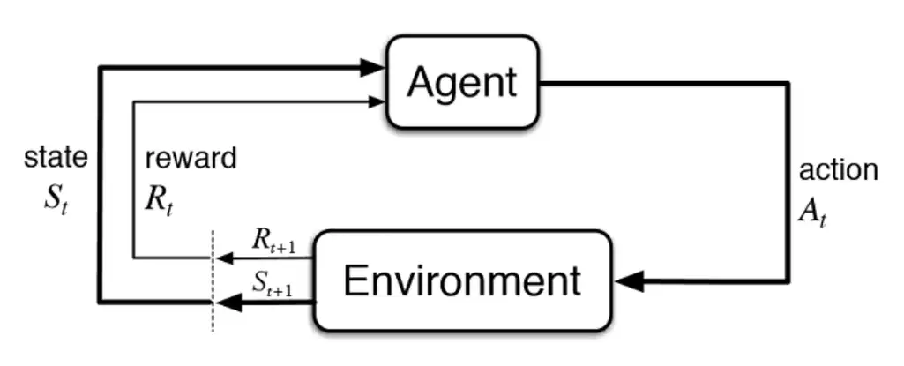
Figure(1): Basic reinforcement learning [1]

Unlike supervised learning, RL does not rely on labeled datasets; instead, it focuses on experience-driven learning through trial and error. This project explores several prominent RL algorithms—Q-Learning, Deep Q-Networks (DQN), Deep Deterministic Policy Gradient (DDPG), and Proximal Policy Optimization (PPO)—to train agents in a variety of simulated environments.
The main objective is to create intelligent models that learn purely from interaction, without the need for pre-existing datasets. The agents were trained and tested in three challenging Gymnasium environments:
- Frozen Lake: a discrete, low-complexity environment ideal for testing basic value-based learning strategies like Q-Learning.
- Lunar Lander: a physics-based control task requiring the agent to learn to land a spacecraft safely, used to evaluate performance of both value- and policy-based methods.
- Bipedal Walker (Normal & Hardcore): complex continuous-control environments where agents must learn to walk using a two-legged robot—especially demanding for advanced algorithms like DDPG and PPO.
Each environment presents unique challenges in terms of state and action space complexity, requiring different algorithmic strategies to achieve optimal performance. This diversity allowed for a comprehensive evaluation of the strengths and limitations of each RL approach.
Reinforcement learning has numerous real-life applications across various industries. In robotics, RL enables machines to learn complex motor skills such as walking, grasping, or flying autonomously. In autonomous vehicles, it helps in path planning and decision-making for safe navigation. RL is also used in healthcare for personalized treatment strategies, in finance for algorithmic trading, and in energy systems for smart grid optimization. Moreover, it powers game-playing agents like AlphaGo and supports recommendation systems that adapt to user preferences over time. These real-world applications highlight the potential of RL to revolutionize systems that must operate in dynamic, uncertain environments.
Through this project, the following goals were achieved:
- Implementation and tuning of four key RL algorithms across different types of environments.
- Training of agents that adapt to their environments through exploration and reward-based learning.
- Comparative analysis of algorithmic performance in terms of learning speed, stability, and final reward outcomes.
By successfully applying RL methods across progressively difficult tasks, this work demonstrates how reinforcement learning can be used to develop adaptive, self-improving agents capable of solving complex control problems without any prior data.

Literature Review
Although this project is primarily based on hands-on implementation, existing community resources, open-source code examples, and widely accepted reinforcement learning algorithms formed the foundation for the work. The literature review here focuses on the theoretical background and practical implementations of the algorithms used, referencing the general understanding from well-known sources rather than specific academic publications.
Reinforcement learning algorithms such as Q-Learning, DQN, DDPG, and PPO are widely used and documented in both research literature and open-source communities. Q-Learning, introduced as a tabular method for discrete environments, laid the groundwork for more advanced methods like Deep Q-Networks, which combine Q-learning with deep neural networks to handle high-dimensional state spaces. DDPG and PPO represent more recent advancements, enabling reinforcement learning in continuous action spaces with improved training stability.
The implementations in this project were guided by publicly available resources, such as:
- Open-source implementations from platforms like GitHub.
- Tutorials and examples from Kaggle and hugging face.
- Community-driven guides and discussions on platforms like Stack Overflow.
- Official Gymnasium documentation for environment specifications and usage.
These resources played a crucial role in understanding the structure of RL agents, how to set up environments, manage experience replay buffers, tune hyperparameters, and visualize performance.
While no formal research papers were directly cited, the project builds upon the collective contributions of the reinforcement learning community. Future work could involve deeper exploration of academic literature to improve algorithmic performance and explore newer or more domain-specific methods.

3. Materials and Methods
This project was implemented using the Python programming language and focused on applying reinforcement learning algorithms across different Gymnasium environments. The environments, tools, and methods were chosen to gradually increase in complexity, allowing for the application of both value-based and policy-based algorithms.
1. Tools and Libraries
The main libraries and tools used in this project include:
- Gymnasium: For simulating reinforcement learning environments.
- PyTorch: For building and training deep neural networks, used in the DQN and DDPG implementations.
- Stable-Baselines3: For using pre-built implementations of advanced reinforcement learning algorithms, particularly PPO in the BipedalWalkerHardcore environment.
- Google Colab and Kaggle (with GPU): Used for training agents in computationally intensive environments such as LunarLander and BipedalWalker.
2. Environments
Three Gymnasium environments were used:
- FrozenLake-v1: A discrete grid-based environment requiring the agent to reach a goal while avoiding holes.
- LunarLander-v2: A 2D physics-based environment where the agent learns to land a spacecraft safely.
- BipedalWalker-v3 and BipedalWalkerHardcore-v3: Continuous control tasks where a biped robot must learn to walk across terrain, with the Hardcore version introducing more difficult obstacles.
3. Algorithms and Implementation
Each environment was paired with an appropriate algorithm based on its complexity and action space:
FrozenLake – Q-Learning (from scratch)
Algorithm Overview:
Q-Learning is a model-free, off-policy algorithm used in discrete action spaces. It learns a Q-table, where each entry represents the expected utility of taking a specific action in a specific state. It updates Q-values using the Bellman equation:
Q(s,a)←Q(s,a)+α[r+γamax​Q(s′,a)−Q(s,a)]
Implementation:
- Trained for 5,000 episodes.
- Training time was under 1 minute due to the simplicity of the environment and algorithm.
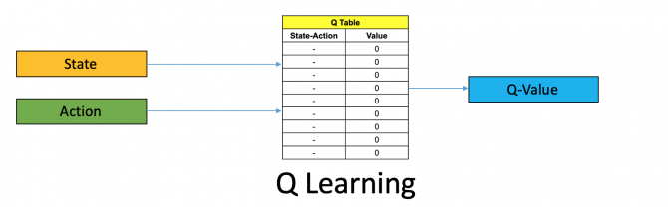
Figure(2): Q learning [2]

LunarLander – Deep Q-Network (from scratch)
Algorithm Overview:
DQN extends Q-Learning by using a deep neural network to approximate the Q-function instead of a table. It uses experience replay and a target network to stabilize training. The loss is calculated as:
L=(r+γ_{a′}max​ Q _{target}​ (s′,a′)− Q(s,a))²
Implementation:
- A deep Q-network (DQN) was implemented using PyTorch.
- Trained for 1,200 episodes, which took approximately 20 minutes on GPU.
- Architecture included a multi-layer perceptron with ReLU activations and two hidden layers.
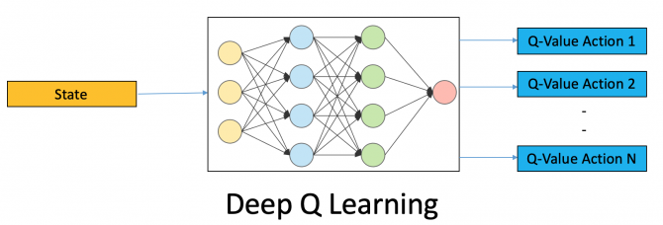
Figure(3):how Deep Q Learning works[2]
BipedalWalker – Deep Deterministic Policy Gradient (DDPG from scratch)
Algorithm Overview:
DDPG is an actor-critic, model-free algorithm for continuous action spaces. It maintains two networks:
- Actor: Outputs the best action given a state.
- Critic: Evaluates the Q-value of state-action pairs.
It uses target networks and soft updates to improve training stability. It also uses noise for exploration in continuous space.
Implementation:
- Used an actor-critic architecture with two networks: actor (policy) and critic (Q-value).
- Implemented in PyTorch and trained for 2,700 episodes around 4 hours on GPU.
- Experience replay and soft target updates were used to improve stability.
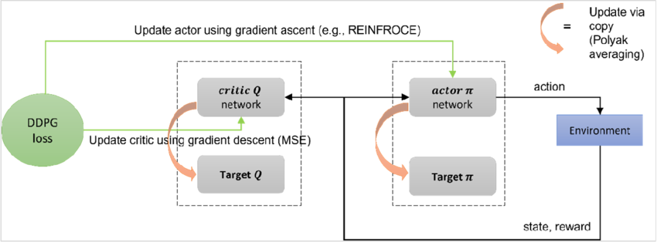
Figure(4): Deep deterministic policy gradient (DDPG)[1]
BipedalWalkerHardcore – PPO (using Stable-Baselines3)
Algorithm Overview:
PPO is a policy-gradient method that balances learning efficiency with stability by clipping policy updates. It optimizes the surrogate objective:
L^{CLIP}(θ)=E^_{t ​}[min(r_{t}​(θ)A^_{t}​,clip(r_{t}​(θ),1−ϵ,1+ϵ)A^_{t}​)]
Where r_{t}(θ) is the probability ratio between the new and old policy.
Implementation:
- Used Proximal Policy Optimization (PPO) from Stable-Baselines3.
- Trained for 150 million timesteps, which took approximately 15 hours on GPU.
- Used VecEnv to parallelize with 64 environments for faster and more stable training.
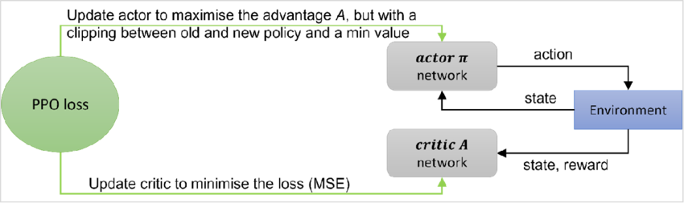
Figure (5): Proximal policy optimization (PPO)
4. Training and Evaluation
Each model was trained using environment-specific hyperparameters, and results were evaluated using:
- Mean rewards per episode.
- Reward convergence graphs.
- Videos recorded during training/testing phases to visualize learning progress.
5. Challenges and Design Decisions
Throughout the project, several challenges were encountered:
- Training Instability: Especially with DDPG and PPO, results varied significantly between runs due to the stochastic nature of training and exploration.
- Slow Learning: Training was extremely time-consuming in environments like BipedalWalkerHardcore even with GPU acceleration.
- Vectorized Environments: For PPO, VecEnv with 64 parallel environments was used to improve training speed and policy stability.
These challenges were addressed by optimizing learning rates, batch sizes, and leveraging GPU hardware wherever necessary.

Results and Analysis
This chapter presents and interprets the results obtained from applying four reinforcement learning algorithms across three environments of increasing complexity: FrozenLake, LunarLander, and BipedalWalker (Normal and Hardcore).
4.1 FrozenLake with Q-Learning
The Q-Learning algorithm showed rapid convergence on the discrete FrozenLake-v1 environment.
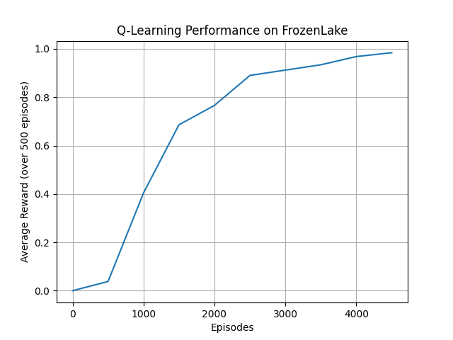
Figure(6): Average Rewards throat training on FrozenLake
- The agent initially performed randomly but gradually learned to reach the goal with increasing consistency after around 1500 episodes.
- By the end of training, the average reward approached 0.98, indicating an 98% success rate in navigating the slippery grid.
Table(1): FrozenLake results information
Metric | Value
Total Episodes | 5000
Final Avg Reward | 0.98
Success rate (100 test episodes) | 100%

The results align with expectations: Q-Learning is effective in small, discrete state spaces. However, the performance was still sensitive to exploration parameters (ε-greedy decay rate).
3.2 LunarLander with Deep Q-Network (DQN)
The DQN algorithm required significantly more training effort due to the continuous state space and sensitive dynamics of the LunarLander environment.
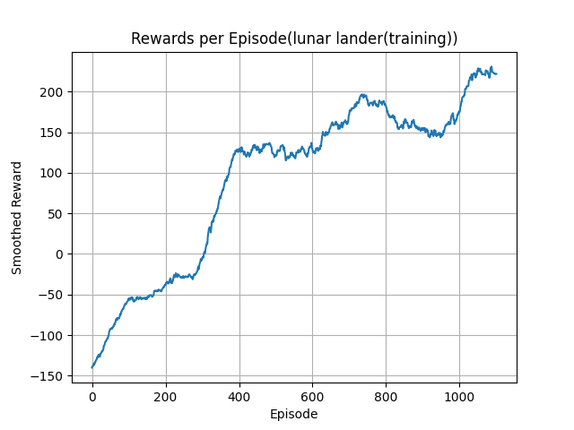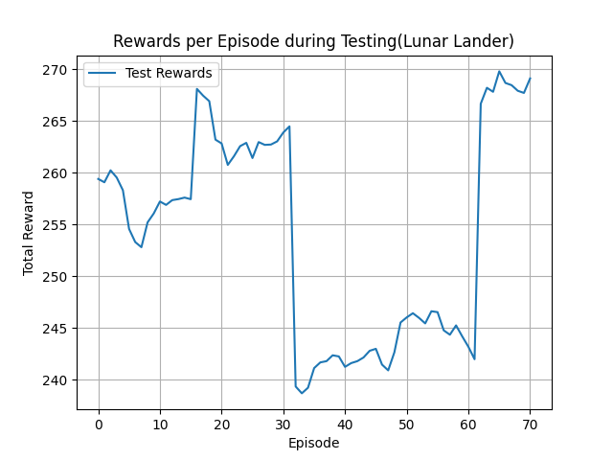
Figure(7): Average Rewards on LunarLander throat training and testing
- Early training showed high instability with frequent crashes.
- Around episode 800, the model began to consistently learn a safe landing policy.
- By episode 1200, the agent achieved average rewards of +200, surpassing the environment’s solved threshold (+200 over 100 episodes).
Table(2): LunarLander results information
Metric | Value
Total Episodes(training) | 1200
Final Avg Reward(training) | 221
First Stable Episode | ~800
Total Episodes(testing) | 100
Final Avg Reward(testing) | 257
Success rate | 95%

Compared to similar open implementations, the learning curve showed slightly slower convergence—likely due to using a simpler network architecture and single-environment training. Nevertheless, results confirm that DQN can successfully learn control policies in moderately complex environments.
3.3 BipedalWalker with DDPG
In the BipedalWalker(Normal) environment, the agent had to learn in a continuous action space, with precise balance and control.
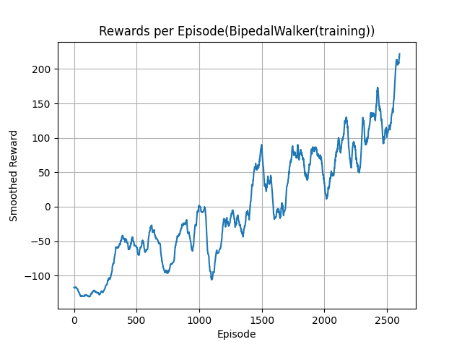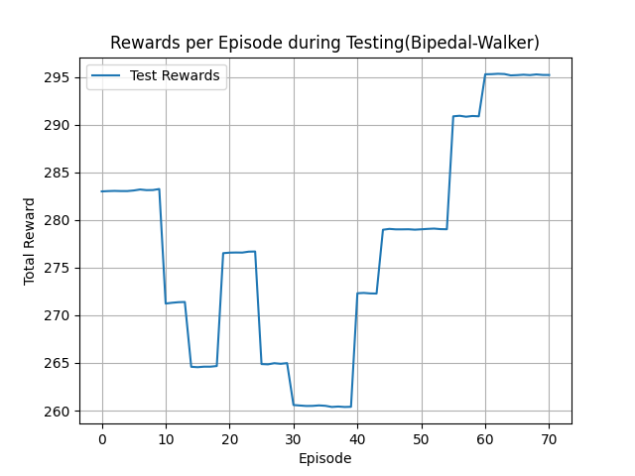
Figure(8): Average Rewards on BipedalWalker(Normal) throat training and testing
- Initial episodes showed erratic behavior and frequent falls.
- From episode 1500 onward, the agent began making progress, showing short walks.
- By episode 2700, average rewards reached >200, which is considered successful performance.
Table(3): BipedalWalker(Normal) results information
Metric | Value
Total Episodes | 2700
Final Avg Reward(training) | 222
Time to Train | ~4 hours
Total Episodes(Testing) | 100
Final Avg Reward(Testing) | 254
Success rate | 90%

A notable observation was the high variance in rewards, typical of DDPG without careful tuning. The performance was sensitive to the noise applied for exploration.
3.4 BipedalWalkerHardcore with PPO (Stable-Baselines3)
This environment presented the most challenging task, featuring complex terrain, gaps, and traps. A prebuilt PPO model from Stable-Baselines3 was trained for 150 million timesteps( using 64 parallel environments (VecEnv).
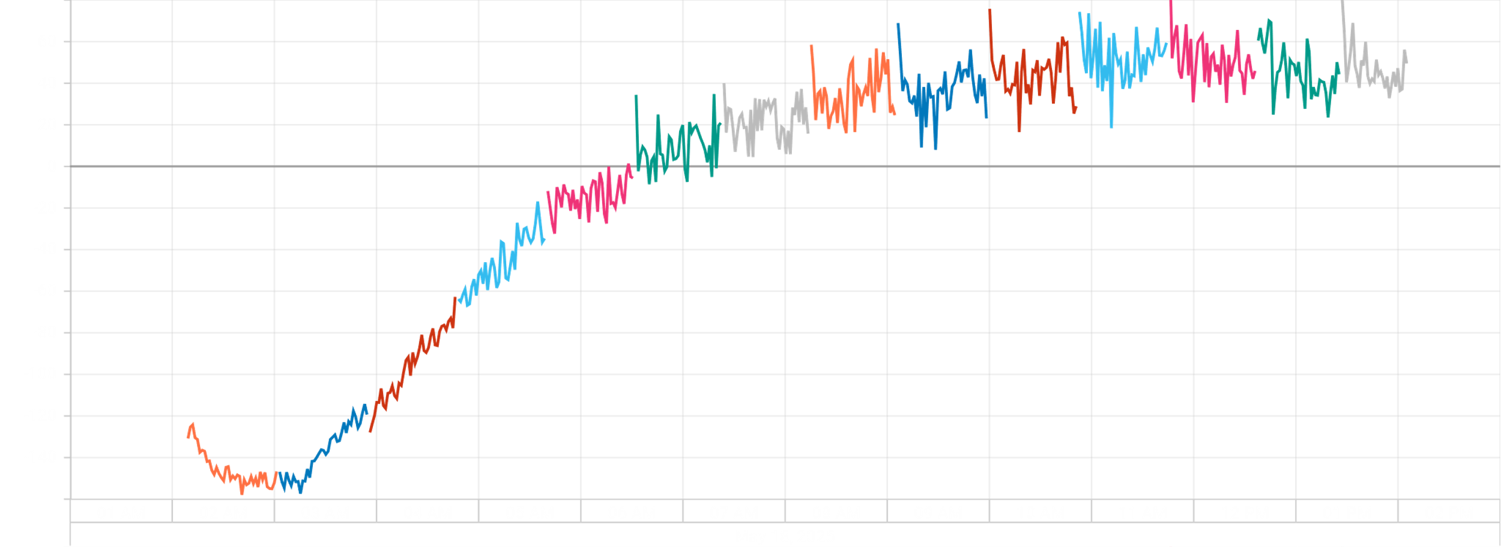
Figure(9): Average Rewards on BipedalWalker(Hardcore) throat time training
-In Figure(9) every line color means 10M steps
- Steady improvements were observed after the first 70M steps.
- Final average rewards exceeded 80, with high consistency in agent behavior.
- Test rollouts showed that the agent could handle rugged terrain with jumps and fall recovery.
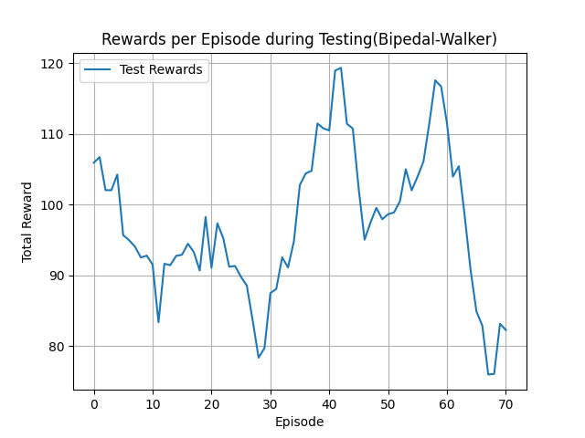
Figure(10): Average Rewards on BipedalWalker(Hardcore) throat Testing
Table(4): BipedalWalker(Hardcore) results information
Metric | Value
Total Timesteps | 140 million
Final Avg Reward(Training) | 80
Parallel Envs Used | 64 (VecEnv)
Training Duration | ~14 hours
Total Episodes(Testing) | 100
Final Avg Reward(Testing) | 125
Success rate | 77%
A challenge noted was instability in early training, likely due to the sparse reward landscape. Use of multiple environments was essential to reach convergence in reasonable time.

Table (5): Summary of results
Environment | Algorithm | Success Threshold | Final Avg Reward | Success rate | Training Time | Notes
FrozenLake | Q-Learning | 1 | 1 | 100% | <1 minute  (CPU) | Stable, tabular convergence
LunarLander | DQN | +200 | 220 | 95% | ~20 minutes  (GPU) | Learned landing policy
BipedalWalker (Normal) | DDPG | +200 | 254 | 90% | ~4 hours  (GPU) | High variance, slower learning
BipedalWalker (Hardcore) | PPO | +120 | 125 | 77% | ~14 hours (GPU) | Required parallel Envs

Conclusions and Recommendations
4.1 Conclusions
This project successfully demonstrated the use of various reinforcement learning (RL) algorithms—Q-Learning, DQN, DDPG, and PPO—across multiple Gymnasium environments of increasing complexity: FrozenLake, LunarLander, and BipedalWalker (Normal and Hardcore). Each algorithm showed strengths and limitations depending on the environment’s structure and complexity:
- Q-Learning proved effective in small, discrete environments like FrozenLake, with fast convergence and minimal computational resources.
- DQN performed well in LunarLander, demonstrating that deep learning can effectively approximate Q-values in continuous state spaces.
- DDPG allowed the agent to learn complex walking behaviors in continuous action spaces, although it required significant training and was sensitive to hyperparameters.
- PPO, applied through Stable-Baselines3 in BipedalWalkerHardcore, showed robustness and efficiency, especially when using vectorized environments for parallel training.
These results validate the core strength of reinforcement learning: the ability of agents to learn from interaction rather than labeled datasets. Moreover, the experiments demonstrated how environment complexity and algorithm design interact to affect performance and learning efficiency.
4.2 Importance and Relevance
This project highlights the practicality of reinforcement learning in autonomous control, robotics, and simulation-based training. The ability of agents to self-learn tasks such as balancing, landing, or walking without prior data is significant in fields like:
- Robotics, where agents can learn to walk, grasp, or manipulate objects.
- Aerospace, where autonomous landers or drones must adapt to unknown conditions.
- Gaming and simulation, where non-player agents can evolve behaviors.
- Healthcare or industrial systems, where decision-making can be learned over time.
The diversity of environments and techniques explored in this project contributes to a broader understanding of RL capabilities and challenges.
4.3 Recommendations
Based on the results and challenges encountered, the following recommendations are proposed:
- Use Vectorized Environments Early: For any environment with sparse rewards or complex dynamics, parallel environments significantly reduce training time and increase stability.
- Implement Logging and Checkpointing: Regular evaluation during training helps detect divergence or plateaus. Saving intermediate models can prevent full restarts after failures.
- Fine-Tune Hyperparameters Systematically: Algorithms like DDPG are highly sensitive.
4.4 Limitations and Misconceptions
Several challenges and misconceptions emerged during this project:
- Non-determinism in RL often leads to different results in separate runs. Even with fixed seeds, instability is common—especially in environments with continuous control.
- Training Time can be extensive, especially without GPU acceleration or vectorized environments. This is a barrier for quick experimentation.
- Overfitting to the environment may occur when using small sets of random seeds or repeating test episodes.
To overcome these, future work should involve:
- Reinforcement learning with curriculum training, starting with simpler versions of environments and gradually increasing difficulty.
- Transfer learning between environments, especially between BipedalWalker Normal and Hardcore, to reduce training time.
- Improved exploration strategies, such as intrinsic motivation or curiosity-based reward shaping, to improve performance in sparse-reward settings.
4.5 Future Work
This project opens many directions for future work:
- Experiment with other algorithms such as A3C, or TQC to improve stability and efficiency.
- Expand to more complex environments or real-world robotics simulators (like MuJoCo or PyBullet).
In conclusion, this project reflects the power and flexibility of reinforcement learning, while also acknowledging its limitations in terms of stability, training cost, and reproducibility. With thoughtful application and tuning, RL continues to offer promising solutions for intelligent autonomous agents in both virtual and real-world environments.

References

1-) Chadi, M. A., & Mousannif, H. (2023). Understanding reinforcement learning algorithms: The progress from basic Q-learning to proximal policy optimization. arXiv preprint arXiv:2304.00026.
2-) Deep Reinforcement Learning: Guide to Deep Q-Learning: https://blog.mlq.ai/deep-reinforcement-learning-q-learning/
3-) Gymnasium Official website https://gymnasium.farama.org/
4-) Stable baselines3 Official website https://stable-baselines3.readthedocs.io/en/master/index.html

